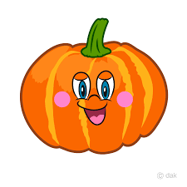

TRICK OR TREAT

TRICK OR TREAT

TRICK OR TREAT

TRICK OR TREAT

TRICK OR TREAT

TRICK OR TREAT

TRICK OR TREAT

TRICK OR TREAT

I have my own special reasons why I can't say, "Trick or Treat." Please take this card as a Thank you.

I have my own special reasons why I can't say, "Trick or Treat." Please take this card as a Thank you.

I have my own special reasons why I can't say, "Trick or Treat." Please take this card as a Thank you.

I have my own special reasons why I can't say, "Trick or Treat." Please take this card as a Thank you.

I have my own special reasons why I can't say, "Trick or Treat." Please take this card as a Thank you.

I have my own special reasons why I can't say, "Trick or Treat." Please take this card as a Thank you.

I have my own special reasons why I can't say, "Trick or Treat." Please take this card as a Thank you.

I have my own special reasons why I can't say, "Trick or Treat." Please take this card as a Thank you.

TRICK OR TREAT

I have my own special reasons why I can't say, "Trick or Treat." Please take this card as a Thank you.

TRICK OR TREAT

I have my own special reasons why I can't say, "Trick or Treat." Please take this card as a Thank you.