**Staying Safe and Healthy**

**Amid the Coronavirus**

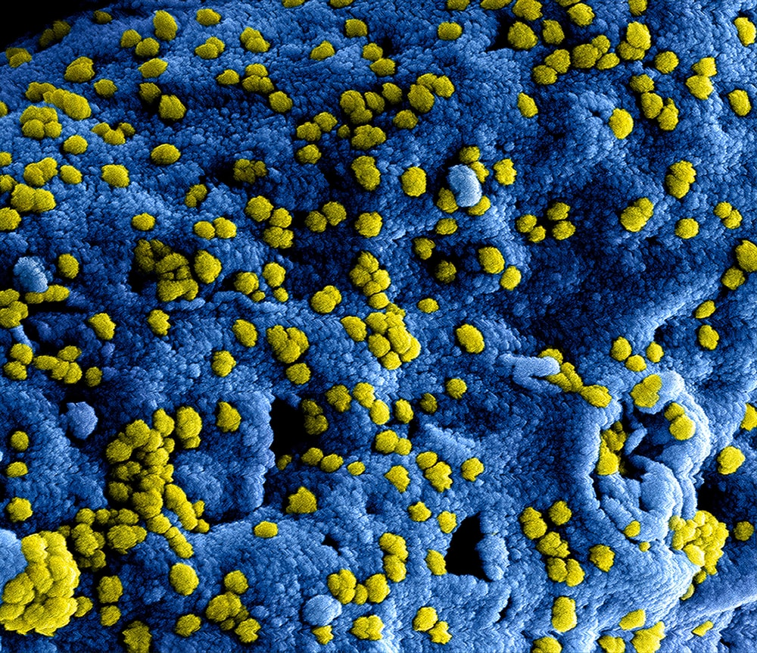

**The coronavirus is a new type of the flu.**

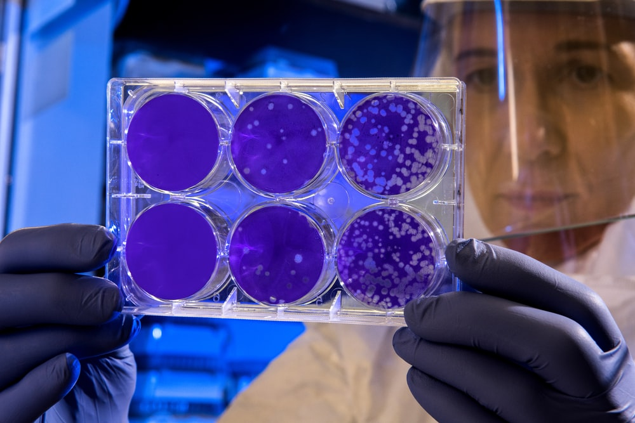

**You are probably hearing lots of adults talking about it.**



**This might make you feel worried, confused, sad, scared, or even curious.**



**Coronavirus could give you a cough, fever, and a hard time breathing. But don’t worry!! It doesn’t stay with people very long and almost everyone will get better.**



**Doctors are working really hard to find a solution as quickly as they can.**

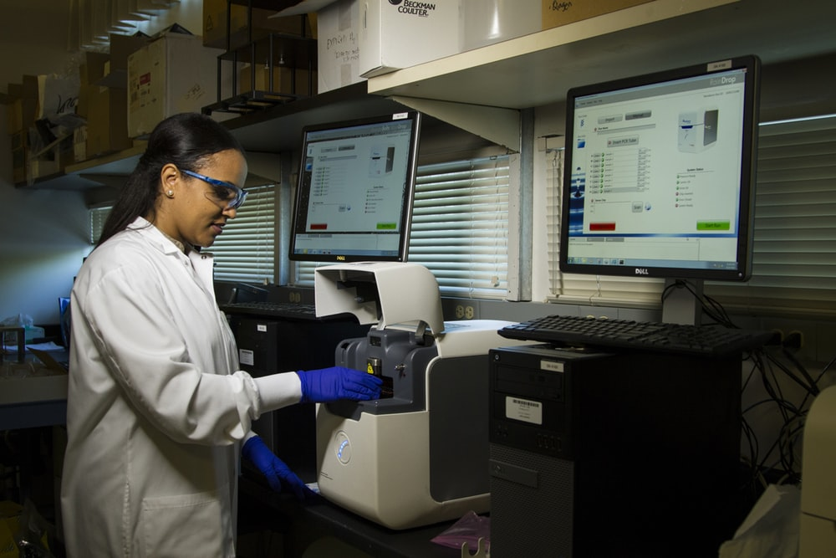

**Until then, you can help keep yourself safe!**

**Wash your hands using soap and water. Try singing the ABC’s or your favorite song to make sure you’re washing long enough.**

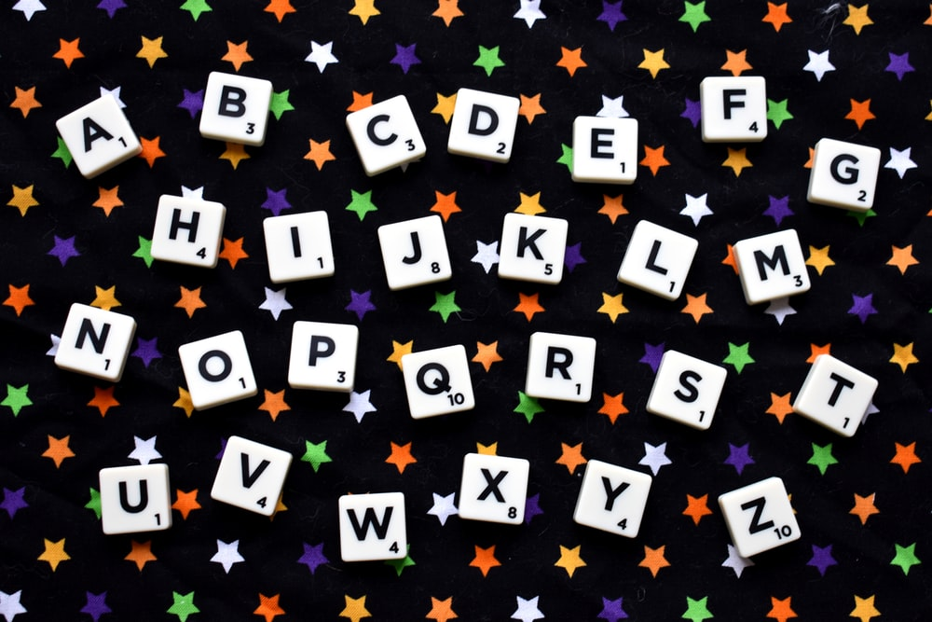

**Use hand sanitizer. Be sure to let it dry on your hands by counting to 10 after you’ve rubbed it in to let it dry.**

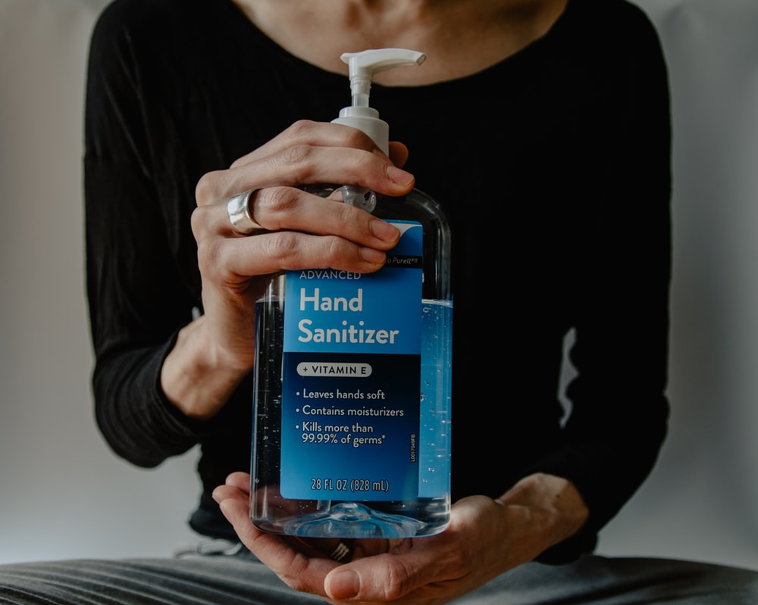

**Wash your hands or use hand sanitizer;**

**when your hands are dirty, after using the bathroom, before eating, and after sneezing or blowing your nose.**

**This will help keep you safe!!**





